Little Traverse Civic Theatre
Auditions:
Monday, August 5th
Wednesday, August 7th

7pm @ Crooked Tree Arts Center
Theatre
451 E. Mitchell Street
Petoskey, MI 49770

Casting
Men: 3 (possibly 4)
Women: 2

Potential Call Backs
Friday, August 9th @ 7pm

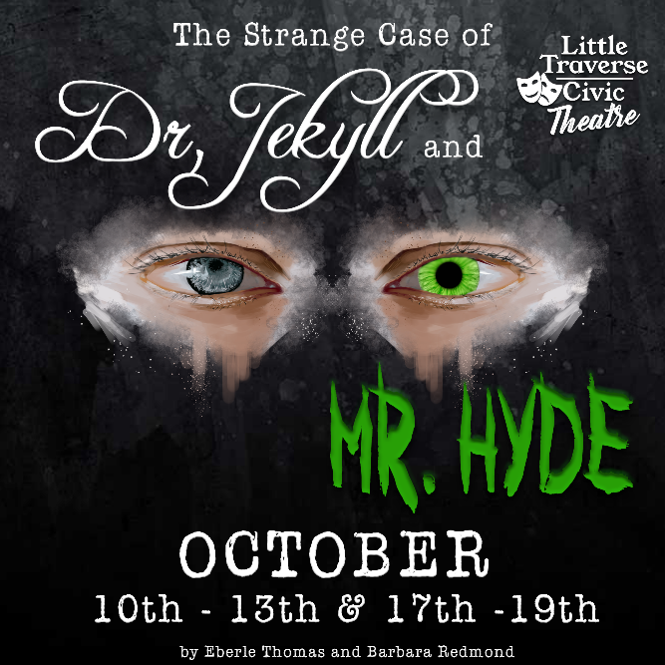
Based on Robert Louis Stevenson’s Novella of the same name this story is ingeniously told from the perspective of Newcomen, the inspector from Scotland Yard who is assigned to this case. He has the grim task of finding the murderous man or beast who has terrorized all of London. Thomas and Redmond do more than a simple retelling of the ancient horror story. In the words of John Gulley, the Artistic Director of the Asolo Touring Theatre, and who originally commissioned the work, "Actors love the Thomas/Redmond plays. The characters talk like real people, and they have real depth and dimension...a formidable feat." Thomas and Redmond have crafted fully fleshed characters out of the dry bones of history, making the story hauntingly real.

Character Descriptions:

Character | Description
Rachel Lanyon | Female: An artist, Dr. Lanyon’s younger sister, and love interest of Dr. Jekyll
Jeanne Poole | Female: Dr. Jekyll’s housekeeper
Inspector Newcomen | Male: Inspector of Scotland Yard assigned to the case
Dowling – Doubled by Newcomen | Lanyon’s Butler
Lord Danvers Carew – Tripled by Newcomen | A lord murdered by Edward Hyde
Dr. David Lanyon | Male: Rachel’s brother, a surgeon and professor of medicine
Dr. Henry Jekyll | Male: Practicing physician and medical researcher
Mr. Edward Hyde – Doubled by Jekyll | A man with “no visible” means of employment

Scripts are Available for Sign Out at the Petoskey District Library (No Account Necessary)
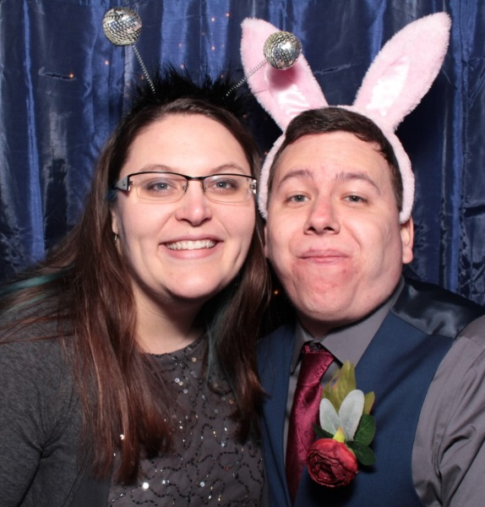
WE ASKED THE DIRECTORS
Amber & Justin Lewis

- How would you describe your take on the play and how that will affect your acting choices?
Amber: Think Jekyll and Hyde meets steampunk! At least that’s what my vision for the show’s visual style is going to be. As for my take on the story, it’s the age old question, is man inherently good or inherently evil? Or maybe a little bit of both. My focus is on the duality of man and working with our actors and technicians to portray this on stage. When it comes to acting choices, I am extremely open and excited to see what everyone brings to the stage. My big emphasis is to keep it real; emotionally and with their movements. I am not a fan of overacting (I put up with it enough at home with my husband’s over the top personality, ha!).
Justin: What my wife said. Except for the over acting. My acting is perfect.

- What characters do you feel are pivotal?
Amber: There are only 5 actors in the show and each one plays a pivotal part or parts as the entire show is put on by them; including set changes that unfold before the audience’s eyes. As for characters the show leans heavily on Newcomen and Jekyll as they have to be able to play multiple parts. Each character has its own unique challenges and emotions to be brought to life and everyone is pivotal to creating a successful production. We are open to splitting up Newcomen’s roles and casting a 6th person to portray Dowling and Lord Carew, but that will be decided after auditions.
Justin: Yep.
- How should volunteers prepare for auditions?
Amber: Read the script and know what you are getting yourself into, particularly anyone interested in Jekyll/Hyde and Jeanne Poole as they have a scene that some may shy away from. Everyone auditioning should understand that the characters are also the stage hands, so along with learning your lines you’ll have to know when and where to move set pieces. Anyone interested in Jekyll/Hyde should start thinking about how to portray each man differently; how he carries himself, his voice, and his facial expressions. We will be doing one scene in particular where we will have someone reading for Jekyll and another for Hyde, we want to hear what you can portray with your voice alone. My last bit of preparation info is that we will not be doing accents.
Justin: Practice.
- What can actors expect from auditions?
Amber: Auditions will comprise of reading scenes from the script, which scenes/pages can be in the Audition Pages download. Depending on audition turn outs we may be asking you to read for a role you did not sign up for. I know auditions can get hectic and we will do our best to make sure that everyone gets to read for each part they are trying out for but to be safe we will ask at the end of each night if anyone would like to read a scene or part they didn’t get to do. After the two nights of auditions we will be contacting actors for call backs.
Justin: 2 directors who are awesome.

The rehearsal schedule will be finalized once casing is complete and will consist of 3 - 4 nights a week.

Important Dates:
Set Move-in: Saturday, September, 28th @ 10:00am

Tech Rehearsal: Saturday, October, 5th or Sunday, October, 6th @ Time TBA

Performance and Call Times:

Thurs- Oct, 10th @ 6:00pm | Thurs- Oct, 17th @ 6:00pm
Fri- Oct, 11th @ 6:00pm | Fri- Oct, 18th @ 6:00pm
Sat- Oct, 12th @ 6:00pm | Sat- Oct, 19th @ 6:00pm
Sun- Oct, 13th @ 12:30 pm

Set Strike: Sunday Oct, 20th
Set Strike is an important part of wrapping up the production. All volunteers are expected to assist with this task. If unable to attend, please discuss your situation with the directors or producers ahead of time.

Audition Scenes:
Audition Scene #: | 1 | 2 | 3 | 4 | 5 | 6 | 7 | 8
 | Sc 6  (18-19) | Sc 7 & 8  (22-25) | Sc 10  (26-28) | Sc 12  (32-35) | Sc 13 & 14  (36-39) | Sc 20  (47-48) | Sc 21 & 22  (49-53) | Sc 30  (63-65)
Rachel Lanyon |  | X |  |  |  | X
Jeanne Poole | X |  |  |  | X |  | X
Inspector Newcomen |  | X |  |  | X |  | X
- Dowling |  |  |  | X
- Lord Danvers Carew
Dr. David Lanyon |  |  |  | X |  | X |  | X
Dr. Henry Jekyll | X | X | X | X |  |  | X
- Mr. Edward Hyde |  |  | X |  | X |  |  | X

